**SYSTEM CODING STANDARD**

In order to use the validation, you must include the word “validate” in your input class name.

**USAGE:**

<input type="text" class="validate">

Specify the allowed characters for the input

**USAGE:**

<input

    type="text"

    class="validate"

    data-allowcharacters="[A-Z][a-z][0-9][ ][@]">

[A-Z] – Allows capital letter from A to Z

[a-z] – Allows small letter from a to z

[0-9 – Allows numbers from 0 to 9

[()] – Allows parenthesis

[any special character] – Specify the allowed special characters

Specify the minimum and maximum characters in an input

**USAGE:**

<input

    type="text"

    class="validate"

    data-allowcharacters="[A-Z][a-z][0-9][ ][@]"

    minlength="2"

    maxlength="20">

If the input field is required, you can also put required word as attribute.

**USAGE:**

<input

    type="text"

    class="validate"

    data-allowcharacters="[A-Z][a-z][0-9][ ][@]"

    minlength="2"

    maxlength="20"

    required>

If the input field is unique, kindly include the unique attribute to the input with the value of the primary key on database

<input

    type="text"

    class="validate"

    data-allowcharacters="[A-Z][a-z][0-9][ ][@]"

    minlength="2"

    maxlength="20"

    required

    unique="1">

In summary, your form group must look like this:

<div class="form-group">

    <label>Firstname <span class="text-danger">*</span></label>

    <input

        type="text"

        id="input_firstname"

        class="form-control validate"

        data-allowcharacters="[A-Z][a-z][0-9][ ][@]"

        minlength="2"

        maxlength="20"

        required

        unique="1">

    <div class="invalid-feedback d-block" id="invalid-input_firstname"></div>

</div>

Note that the id of invalid-feedback is also the same as the input id, but the invalid-feedback has invalid- word before the id. “input_firstname” > “invalid-input_firstname”

If you want to use inputmask plugin to your input field, you must include “inputmask” word to the class name of your input and define your mask as an attribute.

**USAGE:**

<input

        type="text"

        id="input_firstname"

        class="form-control validate inputmask"

        data-allowcharacters="[A-Z][a-z][0-9][ ][@]"

        minlength="2"

        maxlength="20"

        required

        mask="(+63) 999 9999 999">

Inputmask Documentation: https://github.com/RobinHerbots/Inputmask

Integrate select2 plugins into your input.

**USAGE:**

<select class="form-control validate select2" name="role" id="input_role"

required>

    <option value="" disabled selected>Select Role</option>

    <option value="Admin">Admin</option>

    <option value="Operations">Operations</option>

</select>

Include select2 in your class name.

Integrate daterangepicker

**USAGE:**

<div class="input-group">

    <div class="input-group-prepend">

        <span class="input-group-text"><i class="zmdi zmdi-calendar"></i></span>

    </div>

    <input

        type="button"

        class="form-control daterange validate text-left"

        name="birthday"

        id="input_birthday"

        required>

</div>

Include daterange in your class name.

Integrate amount format

**USAGE:**

<input

    type="text"

    class="form-control validate amount"

    name="amount"

    id="input_amount"

    data-allowcharacters="[A-Z][a-z][0-9][ ]"

    minlength="2"

    maxlength="20"

    min="-100"

    max="100000">

You must include the word “amount” in your class name in order to work the amount format. Then specify the min for minimum amount and max for maximum amount.

File uploads

**USAGE:**

<input

    type="file"

    class="form-control validate"

    name="file"

    id="input_file"

    required

    multiple>

If you want multiple uploads, just include an attribute of multiple otherwise remove it.

Initialize DataTables – It destroy and reinitialize datatables

function initDataTables() {

    if ($.fn.DataTable.isDataTable('#tableUserAccount')){

        $('#tableUserAccount').DataTable().destroy();

    }

    var table = $("#tableUserAccount").css({"min-width": "100%"}).removeAttr('width').DataTable({

        proccessing:    false,

        serverSide:     false,

        scrollX:        true,

        scrollCollapse: true,

        columnDefs: [

            { targets: 0, width: 100 },

            { targets: 1, width: 100 },

            { targets: 2, width: 100 },

            { targets: 3, width: 150 },

            { targets: 4, width: 100 },

            { targets: 5, width: 200 },

            { targets: 6, width: 100 },

            { targets: 7, width: 100 },

            { targets: 8, width: 100 },

            { targets: 9, width: 100 },

        ],

    });

}

initDataTables();

DataTables Documentation: https://datatables.net/manual/

Table Content

function modalContent(data = false) {

            let userAccountID = data ? (data[0].userAccountID ? data[0].userAccountID : "") : "",

                skills    = data ? (data[0].skills ? data[0]["skills"].split("|") : []) : [],

                firstname = data ? (data[0].firstname   ? data[0].firstname  : "") : "",

                lastname  = data ? (data[0].lastname    ? data[0].lastname   : "") : "",

                email     = data ? (data[0].email       ? data[0].email      : "") : "",

                mobile    = data ? (data[0].mobile      ? data[0].mobile     : "") : "",

                telephone = data ? (data[0].telephone   ? data[0].telephone  : "") : "",

                address   = data ? (data[0].address     ? data[0].address    : "") : "",

                gender    = data ? (data[0].gender      ? data[0].gender     : "") : "",

                role      = data ? (data[0].role        ? data[0].role       : "") : "",

                birthday  = data ? (data[0].birthday    ? data[0].birthday   : "") : "",

                link      = data ? (data[0].link        ? data[0].link       : "") : "",

                username  = data ? (data[0].username    ? data[0].username   : "") : "",

                password  = data ? (data[0].password    ? data[0].password   : "") : "",

                currency  = data ? (data[0].currency    ? data[0].currency   : "") : "",

                status    = data ? (data[0].status == 1 ? "checked"          : "") : "";

            let button = userAccountID ? `

            <button

                class="btn btn-primary px-5 p-2"

                id="btnUpdate"

                accountid="${userAccountID}">

                UPDATE

            </button>` : `

            <button

                class="btn btn-primary px-5 p-2"

                id="btnSave">

                SAVE

            </button>`;

            let html = `

                <div class="modal-body">

                    <div class="row">

                        <div class="col-md-6 col-sm-12">

                            <div class="form-group">

                                <label for="">Firstname</label>

                                <input

                                    type="text"

                                    class="form-control validate"

                                    name="firstname"

                                    id="input_firstname"

                                    data-allowcharacters="[A-Z][a-z][0-9][ ][@]"

                                    minlength="2"

                                    maxlength="20"

                                    value="${firstname}">

                                <div class="invalid-feedback d-block" id="invalid-input_firstname"></div>

                            </div>

                        </div>

                        <div class="col-md-6 col-sm-12">

                            <div class="form-group">

                                <label for="">Lastname</label>

                                <input

                                    type="text"

                                    class="form-control validate"

                                    name="lastname"

                                    id="input_lastname"

                                    data-allowcharacters="[A-Z][a-z][0-9][ ][@]"

                                    minlength="2"

                                    maxlength="20"

                                    required

                                    value="${lastname}">

                                <div class="invalid-feedback d-block" id="invalid-input_lastname"></div>

                            </div>

                        </div>

                        <div class="col-md-12 col-sm-12">

                            <div class="form-group">

                                <label for="">Email</label>

                                <input

                                    type="email"

                                    class="form-control validate"

                                    name="email"

                                    id="input_email"

                                    data-allowcharacters="[A-Z][a-z][0-9][ ][@][.]"

                                    minlength="2"

                                    maxlength="50"

                                    required

                                    unique="${userAccountID}"

                                    value="${email}">

                                <div class="invalid-feedback d-block" id="invalid-input_email"></div>

                            </div>

                        </div>

                        <div class="col-md-6 col-sm-12">

                            <div class="form-group">

                                <label for="">Mobile No.</label>

                                <input

                                    type="text"

                                    class="form-control validate inputmask"

                                    name="mobile"

                                    id="input_mobile"

                                    data-allowcharacters="[0-9]"

                                    mask="(+63) 999 9999 999"

                                    minlength="18"

                                    maxlength="18"

                                    required

                                    value="${mobile}">

                                <div class="invalid-feedback d-block" id="invalid-input_mobile"></div>

                            </div>

                        </div>

                        <div class="col-md-6 col-sm-12">

                            <div class="form-group">

                                <label for="">Telephone No.</label>

                                <input

                                    type="text"

                                    class="form-control validate inputmask"

                                    name="telephone"

                                    id="input_telephone"

                                    data-allowcharacters="[0-9]"

                                    mask="(99) 9999 9999"

                                    minlength="13"

                                    maxlength="13"

                                    required

                                    value="${telephone}">

                                <div class="invalid-feedback d-block" id="invalid-input_telephone"></div>

                            </div>

                        </div>

                        <div class="col-md-12 col-sm-12">

                            <div class="form-group">

                                <label for="">Address</label>

                                <input

                                    type="text"

                                    class="form-control validate"

                                    name="address"

                                    id="input_address"

                                    data-allowcharacters="[0-9][A-Z][a-z][ ]"

                                    minlength="5"

                                    maxlength="30"

                                    required

                                    value="${address}">

                                <div class="invalid-feedback d-block" id="invalid-input_address"></div>

                            </div>

                        </div>

                        <div class="col-md-4 col-sm-12">

                            <div class="form-group">

                                <label for="">Gender</label><br>

                                <input

                                    type="radio"

                                    class=""

                                    name="gender"

                                    id="input_gender"

                                    value="Male"

                                    ${data ? (gender == "Male" ? "checked" : "") : "checked"}>

                                    &nbsp;Male&nbsp;

                                <input

                                    type="radio"

                                    class=""

                                    name="gender"

                                    id="input_gender"

                                    value="Female"

                                    ${data && gender == "Female" ? "checked" : ""}>

                                    &nbsp;Female&nbsp;

                                <div class="invalid-feedback d-block" id="invalid-input_gender"></div>

                            </div>

                        </div>

                        <div class="col-md-4 col-sm-12">

                            <div class="form-group">

                                <label for="">Role</label>

                                <select

                                    class="form-control select2 validate"

                                    name="role"

                                    id="input_role"

                                    required>

                                    <option

                                        value=""

                                        disabled

                                        ${!data && "selected"}>Select Role</option>

                                    <option

                                        value="Admin"

                                        ${data && role == "Admin" && "selected"}>Admin</option>

                                    <option

                                        value="Operations"

                                        ${data && role == "Operations" && "selected"}>Operations</option>

                                </select>

                                <div class="invalid-feedback d-block" id="invalid-input_role"></div>

                            </div>

                        </div>

                        <div class="col-md-4 col-sm-12">

                            <div class="form-group">

                                <label for="">Birthday</label>

                                <div class="input-group">

                                    <div class="input-group-prepend">

                                        <span class="input-group-text"><i class="zmdi zmdi-calendar"></i></span>

                                    </div>

                                    <input

                                        type="button"

                                        class="form-control daterange validate text-left"

                                        name="birthday"

                                        id="input_birthday"

                                        required

                                        value="${data && birthday ? moment(birthday).format("MMM DD, YYYY") : ""}">

                                </div>

                                <div class="invalid-feedback d-block" id="invalid-input_birthday"></div>

                            </div>

                        </div>

                        <div class="col-md-12 col-sm-12">

                            <div class="form-group">

                                <label for="">Link</label>

                                <input

                                    type="url"

                                    class="form-control validate"

                                    name="link"

                                    id="input_link"

                                    data-allowcharacters="[A-Z][a-z][0-9][.][-][_]"

                                    minlength="10"

                                    maxlength="50"

                                    required

                                    value="${link}">

                                <div class="invalid-feedback d-block" id="invalid-input_link"></div>

                            </div>

                        </div>

                        <div class="col-md-6 col-sm-12">

                            <div class="form-group">

                                <label for="">Username</label>

                                <input

                                    type="text"

                                    class="form-control validate"

                                    name="username"

                                    id="input_username"

                                    data-allowcharacters="[A-Z][a-z][0-9]"

                                    minlength="5"

                                    maxlength="20"

                                    required

                                    unique="${userAccountID}"

                                    value="${username}">

                                <div class="invalid-feedback d-block" id="invalid-input_username"></div>

                            </div>

                        </div>

                        <div class="col-md-6 col-sm-12">

                            <div class="form-group">

                                <label for="">Password</label>

                                <input

                                    type="password"

                                    class="form-control validate"

                                    name="password"

                                    id="input_password"

                                    data-allowcharacters="[A-Z][a-z][0-9]"

                                    minlength="5"

                                    maxlength="20"

                                    required

                                    value="${password}">

                                <div class="invalid-feedback d-block" id="invalid-input_password"></div>

                            </div>

                        </div>

                        <div class="col-md-6 col-sm-12">

                            <div class="form-group">

                                <label>Skills</label><br>

                                <input

                                    type="checkbox"

                                    name="skills"

                                    id="input_skills"

                                    value="CSS"

                                    ${data && skills && skills.some(x => x == "CSS") ? "checked" : ""}> CSS

                                <input

                                    type="checkbox"

                                    name="skills"

                                    id="input_skills"

                                    value="HTML"

                                    ${data && skills && skills.some(x => x == "HTML") ? "checked" : ""}> HTML

                                <input

                                    type="checkbox"

                                    name="skills"

                                    id="input_skills"

                                    value="JS"

                                    ${data && skills && skills.some(x => x == "JS") ? "checked" : ""}> JS

                            </div>

                        </div>

                        <div class="col-md-6 col-sm-12">

                            <div class="form-group">

                                <label>Status <code>*</code></label>

                                <div class="status-toggle d-flex justify-content-start align-items-center">

                                    <span>Inactive &nbsp;&nbsp;</span>

                                    <label class="switch">

                                        <input

                                            type="checkbox"

                                            name="status"

                                            id="input_status" ${status}>

                                        <span class="slider round"></span>

                                    </label>

                                    <span>&nbsp;&nbsp;Active</span>

                                </div>

                            </div>

                        </div>

                        <div class="col-md-6 col-sm-12">

                            <div class="form-group">

                                <label for="">Amount</label>

                                <input

                                    type="text"

                                    class="form-control validate amount"

                                    name="amount"

                                    id="input_amount"

                                    data-allowcharacters="[A-Z][a-z][0-9][ ]"

                                    minlength="2"

                                    maxlength="20"

                                    min="-100"

                                    max="100000"

                                    value="${currency}">

                                <div class="invalid-feedback d-block" id="invalid-input_amount"></div>

                            </div>

                        </div>

                        <div class="col-md-6 col-sm-12">

                            <div class="form-group">

                                <label for="">File</label>

                                <input

                                    type="file"

                                    class="form-control validate"

                                    name="file"

                                    id="input_file"

                                    required

                                    multiple>

                                <div class="invalid-feedback d-block" id="invalid-input_file"></div>

                            </div>

                        </div>

                    </div>

                </div>

                <div class="modal-footer">

                    ${button}

                    <button class="btn btn-danger px-5 p-2" data-dismiss="modal">CANCEL</button>

                </div>`;

            return html;

        }

Opening Add Modal User Account

$(document).on("click", "#btnAdd", function() {

    $("#modal_user_account").modal("show");

    $("#modal_user_account_content").html(preloader);

    const content = modalContent();

    $("#modal_user_account_content").html(content);

    initAll();

});

You must call initAll() function in order for the third party to work.

Opening Edit Modal User Account

$(document).on("click", ".btnEdit", function() {

    const id = $(this).attr("id");

    $("#modal_user_account").modal("show");

    // Display preloader while waiting for the completion of getting the data

    $("#modal_user_account_content").html(preloader);

    const tableData = getTableData("user_account_tbl", "*", "userAccountID="+id, "");

    if (tableData) {

        const content = modalContent(tableData);

        setTimeout(() => {

            $("#modal_user_account_content").html(content);

            $("#btnSaveConfirmationEdit").attr("accountid", id);

            initAll();

        }, 500);

    }

});

Display the preloader first before calling or getting the table data using global function getTableData. Then if it’s success, then print it to the dom element. Just add some timeout to appreciate the loading animation while getting the data. And lastly, call the initAll() function to properly work the third party.

Saving the new added user account

$(document).on("click", "#btnSaveConfirmationAdd", function() {

    /**

     * ----- FORM DATA -----

     * tableData = {} -> Objects

     */

    let data = getFormData("modal_user_account");

    data.append("tableName", "user_account_tbl");

    data.append("feedback", "Your choice");

    /**

     * ----- DATA -----

     * 1. tableName

     * 2. tableData

     * 3. feedback

     */

    const saveData = insertTableData(data);

    if (saveData) {

       tableContent();

    }

})

Using the getFormData function, you can easily get all the input value inside the form and it will return an object of data with the value/key of tableData. Then, in order to use the insertData, you must need to specify which tableName to be use during the insertion, and lastly the feedback that will be use for the notification. Same thing in updateTableData and deleteTableData, but different in content of data.

Adding data to uniqueData array global variable.

let unique = {

    id:       item.userAccountID, // Required

    username: item.username,

    email:    item.email,

}

uniqueData.push(unique);

The key-value pair of id is required in order to perform the existing or unique value properly.

These are the global variables used in this validation. It can’t be used again.

let uniqueData          = []; // Store unique data here

const base_url          = $("#base_url").val();

const differentInputArr = ["input", "select", "textarea"];

const differentInputStr = differentInputArr.join(", ");

const preloader = `

    <div class="loader w-100 p-5 text-center">

        <div class="mt-3">

            <i class="zmdi zmdi-rotate-right zmdi-hc-spin zmdi-hc-3x text-primary"></i>

            <br>

            <p class="text-primary">Please wait...</p>

        </div>

    </div>`;

map function in javascript

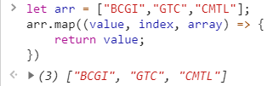ex.

Guide: https://developer.mozilla.org/en-US/docs/Web/JavaScript/Reference/Global_Objects/Array/map

**GLOBAL FUNCTIONS:**

1. **closeModals() –** it hides all open modals
2. **initSelect2(element = null) –** It reinitializes select2 that has class of select2, and/or you can pass an element, id or class name for specific initialization of select2.
3. **initDateRangePicker(element = null) –** It reinitializes the datarangepicker, and/or you can pass an element, id or class name for specific initialization of daterangepicker. It is also a single daterangepicker.
4. **initInputmask(element = null) –** It reinitializes the inputmask, and/or you can pass an element, id or class name for specific initialization of inputmask.
5. **initAmount(element = null) -** It is also an inputmask, but this function focuses only in the format of amount (PHP).
6. **initAll() –** this function will reinitialize select2, daterangepicker, inputmask, and amount.
7. 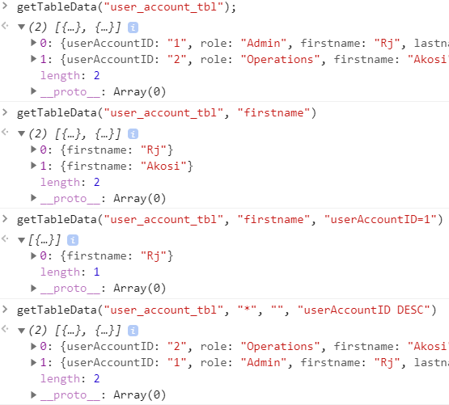**getTableData(tableName = null, columnName = “”, searchFilter = “”, orderBy = “”) –** This function gets the table data from the database. You only have to specify the table name, and the rest is optional.
8. **resetForm(formID = null) –** this function reset the form. It will remove all the validation to the input. It accepts an id of the form as a parameter.
9. **getFormData(formID = null) –** this function gets all the value of the form. It can’t be used for complicated inputs such as getting price for all checked inputboxes.   
     
     
   **NOTE:** If you are using this function, make sure that your input name must be the same as your table column name in your database. Because the basis of the key of this object value is in the input name.
10. 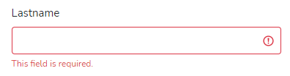**validateInput(elementID) –** It validates the specific input. The elementID can’t be null.
11. **validateForm(formID = null) –** It will validate all inputs in the form. It will then return true if all inputs met the requirements otherwise false.

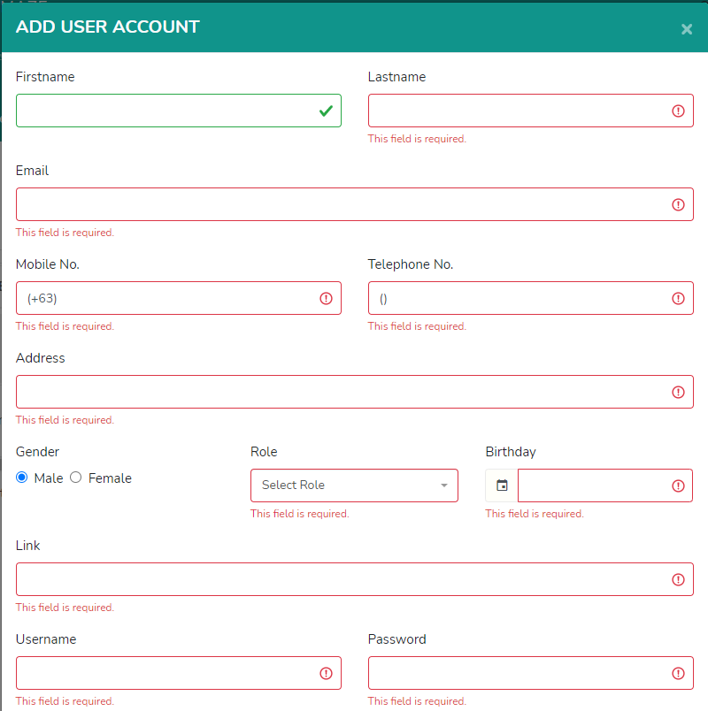

1. **insertTableData(data) –** this function has an access for inserting data to the database. The parameter data is an object value, it consists of tableName, tableData and feedback.   
     
   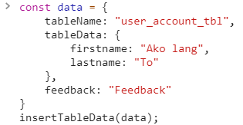
2. **updateTableData(data)** – same as insertTableData aside from whereFilter must be included to the data because this key-value pair will determine on what row or who should be updated.  
     
   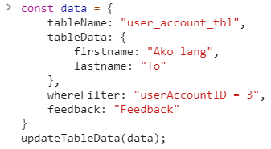
3. **deleteTableData(data) –** this function will delete your data to database. The object data consists of tableName, whereFilter, and feedback.  
     
   